Science is Real
Dear Pro-Life Partners, December 1, 2020

Science, while neither infallible nor divine, is indeed real. Scientific research has resulted in amazing advances in medicine, nature, and technology. Sometimes, it seems, the scientific community loses sight of foundational truths in light of the latest and greatest breakthrough. Sometimes, perhaps, scientific discovery implodes upon itself when “progress” begins to erode morality. If a time traveler from 2020 went back 100 (even 50?) years and wrote a novel from his era, it would read as science fiction! Surely we can welcome the increased quality of life that strides in science bring. However, it would be wise to discern that slapping the word “scientific” on a study does not create legitimacy.

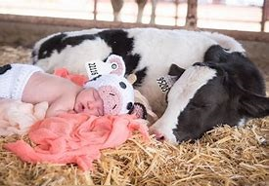
The agricultural community is celebrating a recent vaccine created to prevent miscarriages, or spontaneous abortions, in cows (Life News). I am happy for this bovine breakthrough. After all, cattle represent the livelihood of farmers and ranchers. The U.S. Department of Agriculture estimates that this vaccine will prevent the death of cattle each year that has been responsible for the loss of $10 million annually in California, Oregon, and Nevada alone. How wonderful…how…inconsistent. This celebratory vaccine will generate income by saving lives. Great! Meanwhile, the abortion industry generates profits by destroying lives. So, the spontaneous abortion of cows is being eliminated while the elective abortion of humans is being exacerbated. We mourn the former and market the latter. Chalk one up for science.

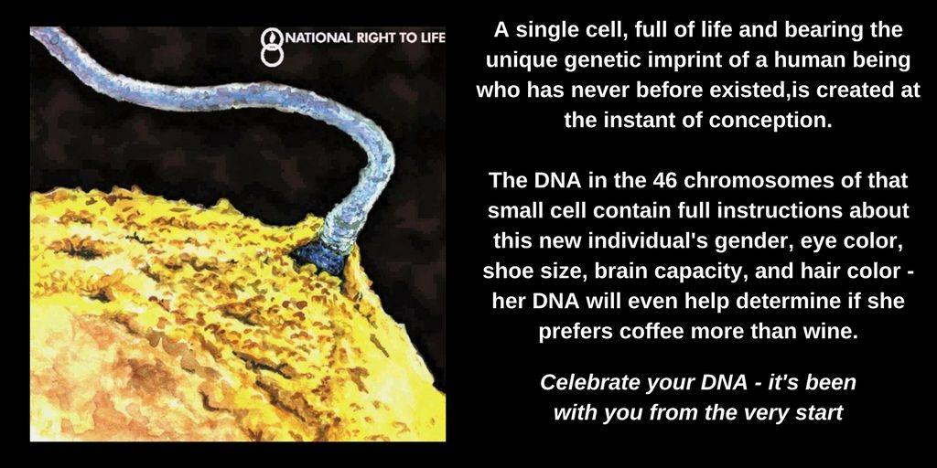
One scientific debate that lies at the heart of the pro-life/pro-choice debate would be when life begins. Richard Paulson, former president of American Society for Reproductive Medicine, writes, in “Why life doesn’t begin at conception” that this concept is a religious definition of life, not a scientific one. He argues that the “highly inefficient process” of human reproduction supports his claim because chromosomal abnormalities increase with a woman’s age, resulting in more miscarriages, and even normal embryos result in a live birth only half the time (NRL News). Others argue in his defense that simply being alive and human, like a kidney, does not give it moral rights. These are misdirects. The failure of a fertilized egg to implant or come to term simply illustrates life’s end, not it’s beginning. Also, the unborn child is not a part of a human being, but a whole, independent organism with a beginning and an end. The case that life begins at conception is the conclusion of embryology, and there are scores of medical resources to affirm this fact.

So, when we are encouraged ad nauseum to “listen to science,” be aware that studies that support abortion procedures or abortifacients are typically funded by global abortion supporters (NRL News). To deny long-held scientific evidence regarding the humanity of unborn children, abortion advocates are forced to dehumanize them as a “clump of cells.” Yet even abortion facilities do not deny that by 5-6 weeks “A very basic beating heart and circulatory system develop” (Planned Parenthood website). They also acknowledge that at 7-8 weeks the heart has formed, webbed fingers and toes develop, the arms bend at the elbows, and external ears, eyes, eyelids, liver, and upper lip begin forming. A doctor describes an unborn child one month after conception: “By 30 days, the baby—one quarter of an inch long—has a brain of unmistakable human proportions, eyes, ears, mouth, kidneys, liver, an umbilical cord, and a heart pumping blood he has made himself” (NRL News). That’s a pretty sophisticated “clump of cells.”

Strides in technology are helping to affirm the humanity of unborn children. The use of ultrasound is becoming an increasingly powerful tool to persuade mothers to choose life over abortion. Astounding 3D technology allows blind parents to feel their unborn baby’s face and experience an ultrasound more fully. Formerly used solely for diagnostic purposes, 3D ultrasounds provide images of a baby’s face at 18-22 weeks (NRL News). The ultrasound photo below uses 4D technology. A reporter described it this way, “While such images won’t quell the abortion debate anytime soon, their beauty alone deserves pause and admiration” (NRL News).
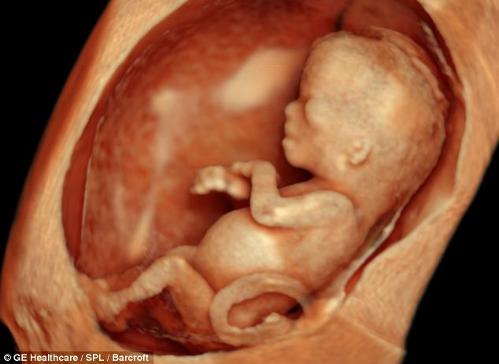

Partnering with you for Life,

Linda Verhulst, MRL-WR

